**IVEN Use in MATLAB**Jessica E. Forsyth

This tutorial describes how to run IVEN in MATLAB, all examples and figures are shown using MATLAB2020. Before working through this tutorial, please make sure you data is formatted as described in the ‘Data Assembly for Input into IVEN Pipeline’ tutorial.

MATLAB software-

MATLAB software is often available within institutions, students can download MATLAB for a reduced fee, but otherwise a licence must be purchased. Check with your institution whether a site licence is available/has been purchased. Or go to <https://uk.mathworks.com/products/matlab.html> for more information.   
***NOTE: YOU MUST HAVE THE STATISTICS AND MACHINE LEARNING TOOLBOX INSTALLED.***

1. Double check your data is in the correct format with correct columns and column order (pad your data if need be). See ‘Data Assembly for Input into IVEN Pipeline’ tutorial.
2. Download the ‘.m’ files from our GitHub. Save them into your MATLAB folder that will have automatically been created during the installation of the software. (This is often located on the C drive or equ.)
3. 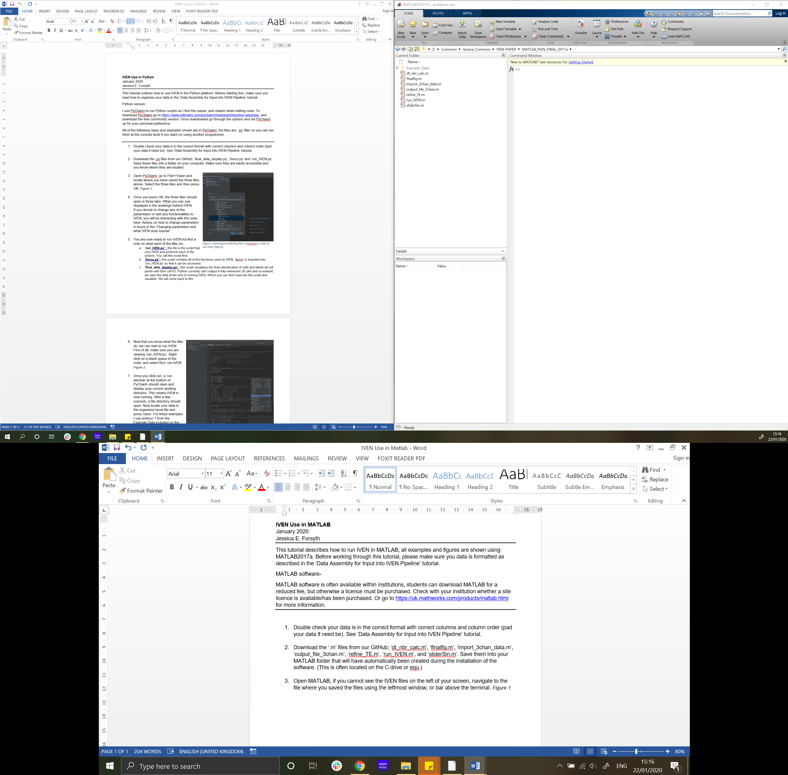Open MATLAB, if you cannot see the IVEN files on the left of your screen, navigate to the file where you saved the files using the leftmost window, or bar above the terminal. *Figure 1.*

Figure 1 Left window allows you to navigate to where your files are saved, or bar above this, currently showing Z: Common: ......., step 3.

1. NOTE: if you are running IVEN on a Mac, please open the output_file_3chan_data.m file, and comment out line 29 by typing a percentage sign (%) infront of ‘xlswrite…’. The text should turn to green. Now delete the ‘%{‘ from line 32 and the ‘}%’ from line 43. The data will now output as a text file which you can later open using excel and delimit the columns.
2. Once you are in the correct directory that contains the IVEN ‘.m’ files. You are ready to start. To edit or view any of the scripts (‘.m’ files), click on the file in the left window. This will either open a pop-up window with the script, or open a window displaying the script docked in the main MATLAB window. (However you don’t need to open the scripts in order to run them).   
   A quick note on what each of the scripts do;
   1. ***‘dt_nbr_calc.m’*** : this function is what calculates the DT and calculates the number of neighbours of cells. This script also corrects the calculated numbers of neighbours using the implemented threshold.
   2. ***‘finalfig.m’*** : this function generates a final figure showing the final classification of cells and cell ID labels.
   3. ***‘import_3chan_data.m’*** : importing of data into IVEN, 3chan simply indicated this function imports the green, red and far-red channels. So data must be padded if these three channels are not actually present- see data assembly tutorial for more information.
   4. ***‘import_2chan_data.m’***; importing of two channel data into IVEN, please avoid and pad data, this is from existing testing of pipeline.
   5. ***‘output_file_3chan.m’*** : outputting of data, again 3chan simply refers to outputting green, red and far-red data.
   6. ***‘run_IVEN.m’*** : this script runs IVEN and calls all other functions.
   7. ***‘TE_selection.m’*** : to reclassify cells as either inside or outside, this script is run to allow manipulation of the shrink factor that changes the Convex Hull, or cell specific cell reallocation.
   8. ***‘thresholdChoice.m’***; generates GUI to select how you would like to threshold your neighbour data.
3. 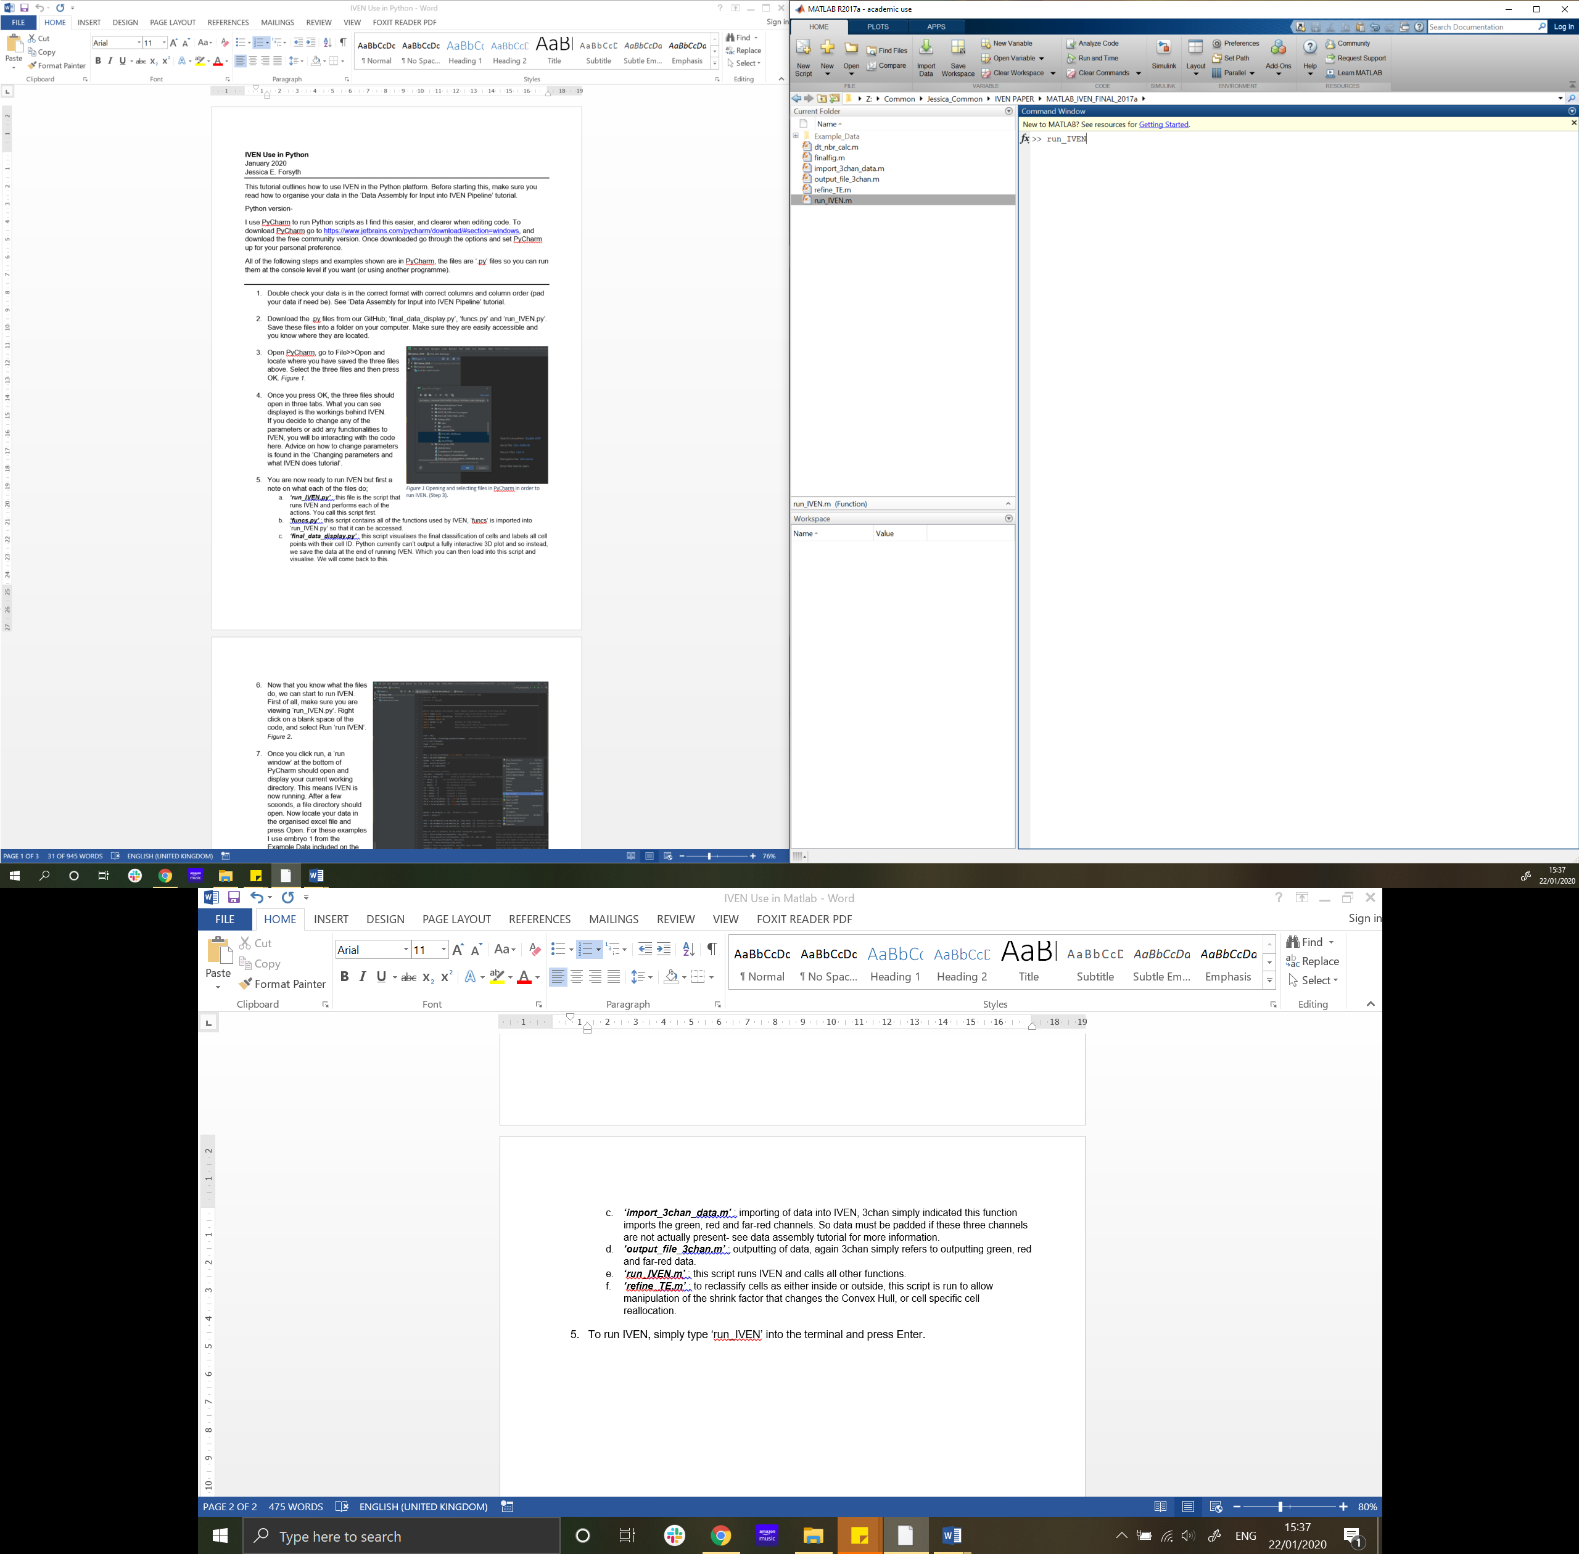To run IVEN, simply type ‘run_IVEN’ into the terminal and press Enter.

Figure 2 How to run IVEN from the MATLAB terminal. Press Enter to run, step 5.

1. 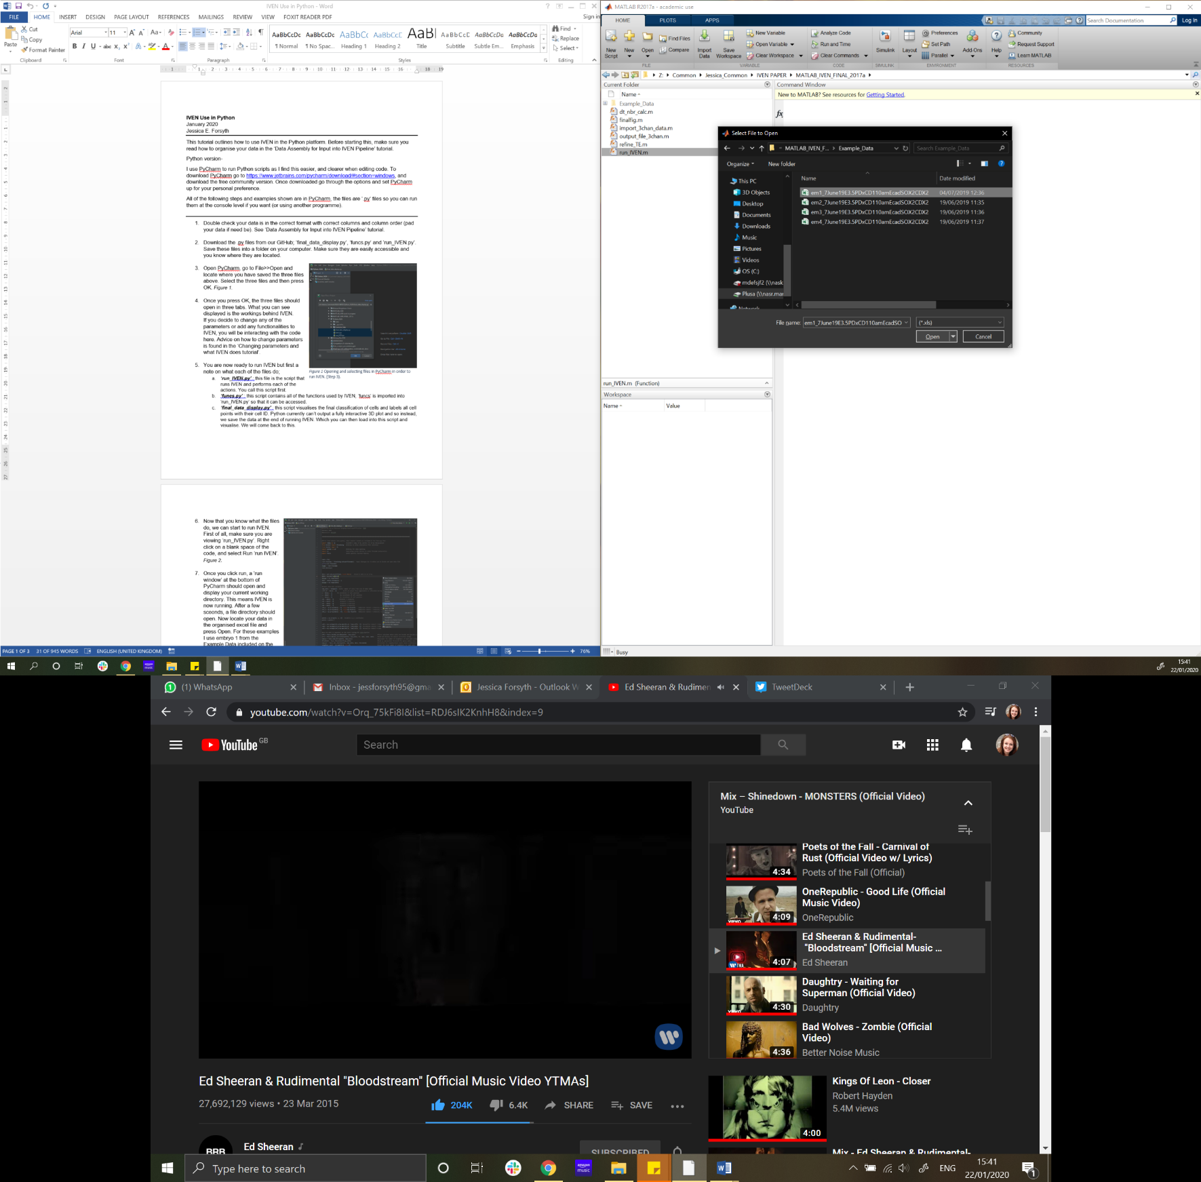Once you press Enter, a file dialogue window should pop up, locate the Excel file(s) you want to analyse and press Open. If you would like to process multiple files, use Ctrl to select all files you would like to process and then press Open. *Figure 3.*
2. After pressing Open, wait a couple of seconds, you should see the filename you selected displayed in the

Figure 3 Open file for analysis, step 6.

1. A pop-up window should appear and display a schematic of your sample. The points shown within the window are representative of the nuclei centres input from your data file. Points surrounded by blue are inside cells and points surrounded by white are outside cells. *Figure 4.*

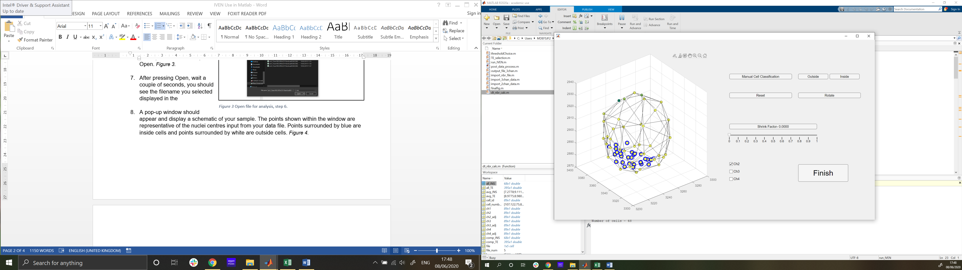

Figure 4 Graphical user interface to enable correction of cell type classification (inside versus outside).

1. This GUI (shown in Figure 4) allows you to interact with the points and rotate them, plus change the cells’ classifications. To rotate the embryo simply drag on the white area of the 3D plot and drag, this takes some getting used to so go slowly. To view other Channel intensities (from your confocal image perhaps showing protein expression), use the checkboxes to the lower right of the 3D plot. Ch2 displays intensities in green (green high , yellow=low, Ch3 (red high, yellow low) and Ch4 (white high, black low). Use these intensities, if appropriate to help with reclassification of cells. E.g. if CDX2 was used in Ch2, any cells shown with green centres I would mark as outside cells.
2. To reclassify cells, click the ‘Manual Correction’ Button. This will change your cursor to a ‘brush tool’. Select the centre of the cell you would like to change classification of, and then either select the ‘Outside’ or ‘Inside’ button as appropriate. You should see the outline of the point change from blue to white or vice versa. If you need to rotate the plot again, press the ‘Rotate’ button, your cursor will change again and you can rotate the plot as before, then if you want to edit the classification press the ‘Manual Correction’ button as before.
3. Another way to edit cell classification is using the shrink factor of the Convex Hull (slider bar). By increasing the value of the shrink factor, you internalise the Convex Hull (incorporate more cells into the outside cell group). Change this slider to reallocate cells.
4. Once you are finished with your classification of cells, press the finish button.
5. After this, another window should appear (Figure 5) that asks what threshold you would like to apply to the dataset. This threshold is the neighbour distance threshold applied to account for the presence of cavities or other abnormalities. This threshold should be chosen **appropriately** for your data, see tutorial for this. Select from the three options your method of thresholding;
   * 1. Automatic; threshold is calculated from the data using the interquatile mean and 75th percentile of the distance between neighbours distribution. The value of k can be chosen appropriately to change how strict the thresholding is.
     2. Pre-set value; choose the value of your threshold independently of the data (make sure this is applied in the same units as your input x, y, z coordinates (e.g. micrometers or pixels).
     3. No applied threshold; simply use the Delaunay Triangulation to calculate the number of neighbours, do not check the distances between neighbours. All identified neighbours are assumed true.
     4. Outside vs Inside automatic method is the same as option 1, but calculated for inside and outside cells separately.

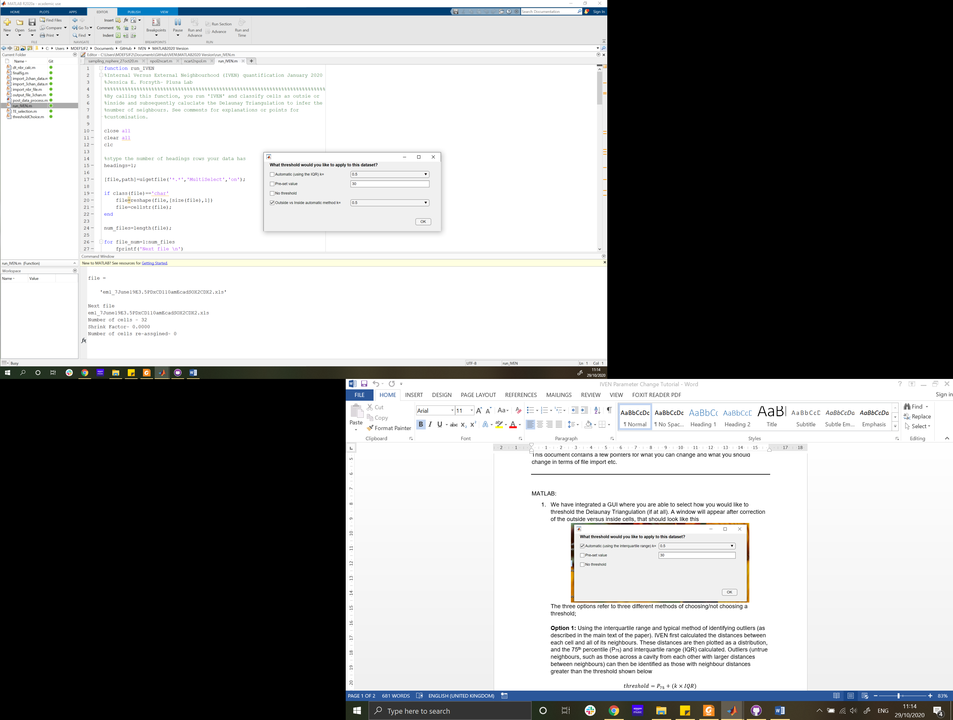

Figure 5 Threshold selection GUI.

1. Press ‘OK’ once you have selected your thresholding method. To allow for accountability and re-processing of data, IVEN now outputs and saves a ‘.fig’ file with a labelled 3D schematic (similar to the one shown in the first GUI) of the dataset along with finalised cell classifications. Additionally IVEN outputs valuable information (file name, number of cells, shrink factor, number of cells re-assigned, threshold applied, file saved status PLUS any errors) to the Command Window as print statements. This can be copied and pasted into a document and kept for further use.
2. IVEN will then continue to the next file, and repeat the above steps (8-14) for each file. Once all files are processed, a message ‘All files processed.’ will appear in the command window.